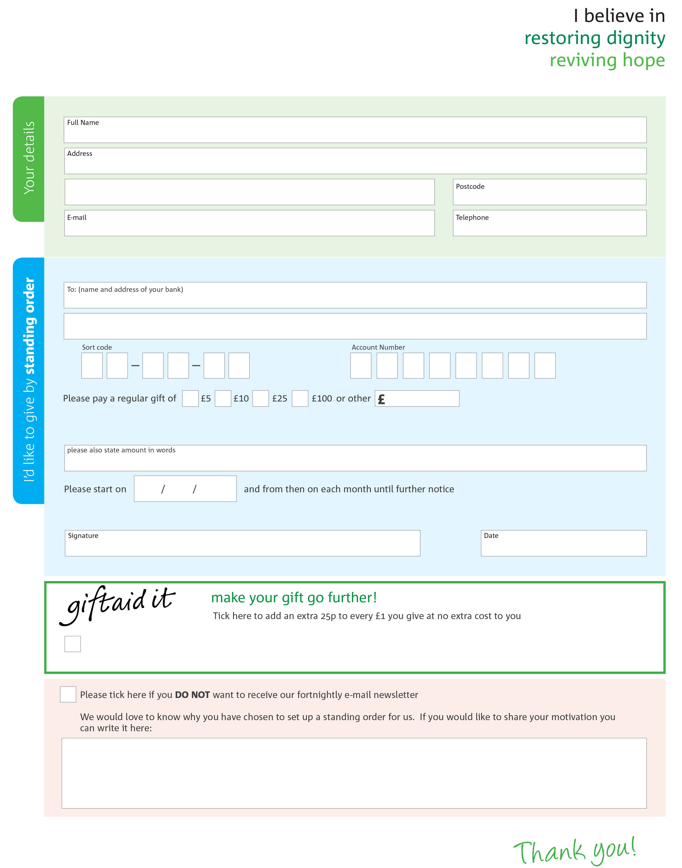
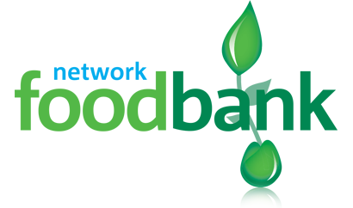
_{To CVO(EA) each month,}
This cancels any previous standing order instructions to CVO(EA)
Yes, I pay tax in the UK. Please treat all donations I make or have made to CVO(EA) for the past four years as gift aid donations until further notice.
I confirm I have paid or will pay an amount of Income Tax and/or Capital Gains Tax for each tax year (6 April to 5 April) that is at least equal to the amount of tax that all the charities or Community Amateur Sports Clubs (CASCs) that I donate to will reclaim on my gifts for that tax year. I understand that other taxes such as VAT and Council Tax do not qualify. I understand the charity will reclaim 25p of tax on every £1 that I give.
bank details: Royal Bank of Scotland
Address 96 John Finnie Street, Kilmarnock
Sort code 834500
Account number 00645364
Reg. Charity No: SC024931 Reg. in Scotland
Please send your completed form to
CVO(EA)
16 Brewery Rd
Kilmarnock
KA1 3GZ

_{Ayrshire East Foodbank}

_{– managed by CVO(East} Ayrshire)
Managed by CVO(East Ayrshire)

